Techno Machine Tools

Survey no:126/A/1, DOOR NO: 4-132-9/A/2, Gandimaisamma X Road,

Medchal Malkajgeri,Hyderabad-500043.Telangana, India.

(Machine tool manufacturers)

T.SIVARAMAKRISHNA
ME., MBA.
------------------------------------------------------------------------------------------------------------

TMT/Yogesh /S096/2025 07.03.2025

To,
Yogesh Jariwala
Mobile No :+919033310640
Email : yogesh.jariwala@ymail.com
City : Surat
State : Gujarat

Dear Sir

SUB :- SUPPLY OF FIXED ROD LEVELING AND CUTTING MACHINE

We thank you for your enquiry regarding above equipment .We are glad to inform you that, we would be in a position to do the required equipment. The following are specifications and description of the machine along with our terms and conditions.

Specifications of the equipment:

1) Maximum rod diameter : 10 MM

2) Type of body : M.S fabricated

3) Maximum length : 5000 mm

4) Drive to mill :3 HP

5) Power pack : 5 HP

6) Maximum pressure : 180 kg/cm2

7) Operation Pressure : 150 kg/ cm2

8) Hydraulic power pack : Yuken (japan)/ Rexroath

Contd –2

!! 2 !!

9) Total power : 8 HP

10) Electricals : Siemens/ABB

11) de coiler 500 kg

S No | Description of the unit | Offer
1. | Rod cutting press along with de coiler and hydraulic cutting unit and die of speed 15 meters/min | Rs 2,50,000/- (Rupees Two Lakhs Fifty Five Thousand only)

GENERAL TERMS & CONDITIONS:

1 Price quoted per unit ex-work. Hyderabad.
2 Following charges are additional to your account.
Freight Charge : As actual to be borne by you.
- Sales Tax : Gst 18 % extra
- Packing charge : As actual to be borne by you.
- Insurance : As actual to be borne by you.
3 Payment : 50% advance along with order balance before delivery
but after inspection at our works.
- Delivery : 2-3 weeks from date of techno-commercially clear
purchase order.
- Validity : One month from the date of submission.
- Inspection : Inspection at our works prior to dispatch.
- Warranty : The machine is warranted for a period of 12
months from the date of dispatch against any
manufacturing defects/faulty material or bad
workmanship of any part or component but not
against any kind of abnormal or improper use of
machine. Defective part or component will be
replaced or repaired free of cost. Electrical
components are outside the scope of this
warranty.
- Commissioning : Erection & commissioning done by you, but if
required technical support & guidance provide by
us at additional cost.
NOTE:

- Oil is not in scope of our supply.
- Raw material for trial is arrange by you at your cost.

We are sure you will find our offer in line with your requirements. Should you require any further clarification please call us on mobile number 9246221106.

Thanking you and assuring you of our best services.

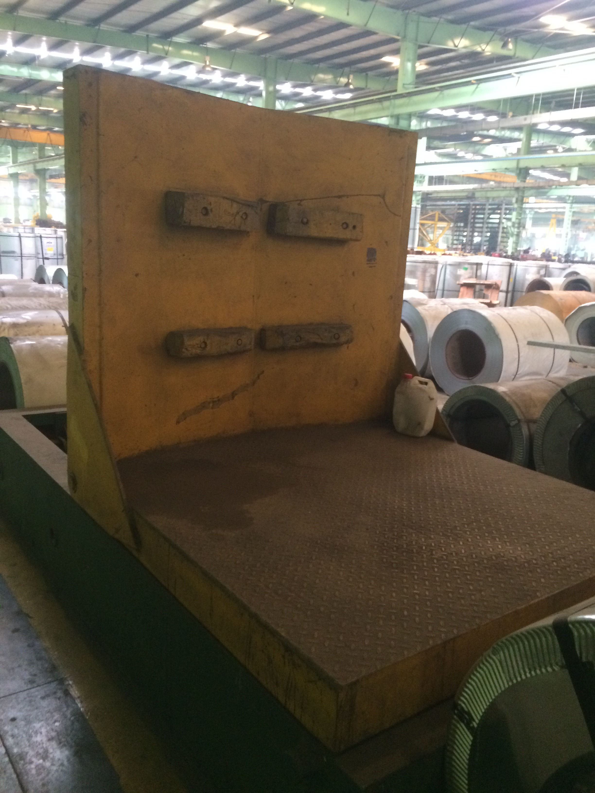

For TECHNO MACHINE TOOLS

( T. SIVARAMAKRISHNA)

